3.2 I can reflect on the efficiency of project management techniques

In the project we did in the group we used Agile method when making our web pages and CSS and combining them. We used Critical Path Analysis through a Gantt chart as well, which helped us navigate through the tasks and combine two at the same time so that it was done quicker.

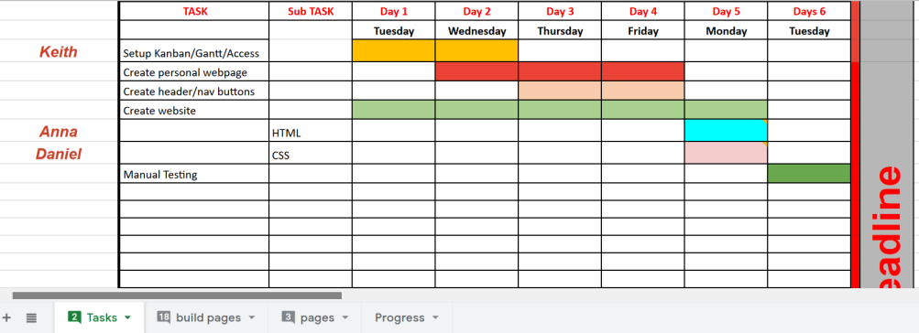

[Above is the image of our Gantt chart]

The main pro to us using Agile method in the project we did compared to Waterfall was that it made everything so much faster, we had a week and the project was small and Waterfall method would not have sufficed because we would have been doing more things slower and the team would have struggled to complete things on time. Plus SCRUM helped us delegate tasks as well.

Waterfall techniques can be used on major projects which use a bigger time-frame and bigger budget, I.e making a new operating system or some other major project.